V Parikshith

SRN: PES1PG20CA046

***Factorial of a number***

import math

x=int(input("Enter a number "))

print("Factorial = ",math.factorial(x))

Output:

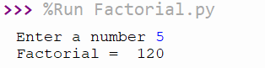

***Distance between two points***

import math

x1=int(input("Enter x1 "))

x2=int(input("Enter x2 "))

y1=int(input("Enter y1 "))

y2=int(input("Enter y2 "))

distance = math.sqrt((x2-x1)**2+(y2-y1)**2)

print("distance: ",distance)

Output:

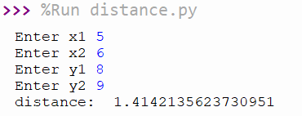

***volume of a cone by taking user input***

import math

r=int(input("Enter radius: "))

h=int(input("Enter height: "))

area=(1/3*math.pi*(r*r)*h)

print("Area: ",area)

Output:

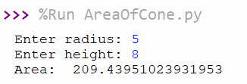

***Compound Interest based on user’s input***

import math

p=int(input("Enter principle amount "))

i=int(input("Enter interest "))

y=int(input("Enter years "))

a = (p*(1+i)**y)

print("Final amount: ",a)

Output:

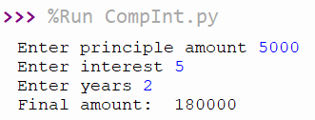

***area of triangle given the 3 sides***

import math

a=float(input("enter side 1 "))

b=float(input("enter side 2 "))

c=float(input("enter side 3 "))

s=(a+b+c)/2

area=math.sqrt(s*(s-a)*(s-b)*(s-c))

print("area: ",area)

Output:

